CHAPTER 1
INTRODUCTION
  - PERSCPECTIVE

In the present job market, resumes play an important role in connecting job seekers with suitable employment opportunities. A resume presents a candidate’s educational qualifications, technical skills, projects, and work experience. However, recruiters often receive numerous applications for a single job opening, making manual screening time-consuming. Similarly, students may find it difficult to identify gaps in their resumes and understand how well their profiles match specific job requirements.

The AI Resume Analysis and Recruitment System is a web-based application designed to simplify resume evaluation and recruitment activities. It provides separate interfaces for students and recruiters. Students can upload their resumes, analyse their compatibility with job descriptions, identify missing skills, and receive improvement suggestions. Recruiters can manage job postings, screen multiple resumes, and identify candidates whose profiles are relevant to available positions.

The system uses Natural Language Processing (NLP) techniques to extract relevant information from resumes. The spaCy library supports text processing and skill extraction, while Sentence Transformer models generate text embeddings to compare resumes and job descriptions based on semantic similarity. Machine learning and FAISS-based vector search further support candidate matching and information retrieval. The system also integrates generative AI capabilities for selected tasks, including resume improvement suggestions and interview preparation.

The frontend is developed using React.js, while the backend is implemented in Python with FastAPI. These components work together to provide the user interface, manage requests, process resumes, and connect the application with its AI/ML modules. By integrating resume analysis, job matching, and interview practice into a single platform, the system aims to support students in career preparation and help recruiters reduce the effort required for preliminary candidate screening.
The analysis results depend on the quality of the uploaded resumes and the capabilities of the underlying models. Therefore, the system is intended to assist users in evaluating resumes and comparing candidates rather than replace human judgement in recruitment decisions.

  - PROBLEM DESCRIPTION
Students often find it difficult to create a professional resume that clearly presents their qualifications, technical skills, projects, and experience. They may spend considerable time searching for suitable resume templates and modifying their resumes to meet different job requirements. Checking whether a resume meets Applicant Tracking System (ATS) requirements can also be challenging, as students may not know which keywords or skills are missing. Without proper guidance, identifying areas for improvement and preparing a resume that matches a particular job description becomes a time-consuming process.
Another major challenge faced by students is the need to use multiple websites and applications for different career preparation activities. Resume building, ATS score checking, job matching, and interview practice are often performed using separate platforms. Switching between these tools makes the preparation process less convenient and can make it difficult for students to track their progress. Students also need a way to identify their skill gaps and receive relevant suggestions to improve their resumes and interview performance.
HR professionals face difficulties in manually reviewing a large number of resumes for each job opening. Screening candidates based on their qualifications, technical skills, and experience requires considerable time and effort. Resumes may follow different formats and describe similar skills using different terminology, making consistent comparison difficult. In the absence of automated resume screening and job-matching facilities, identifying suitable candidates and preparing a shortlist can become a lengthy process, increasing the workload of recruitment teams and delaying candidate selection.

1.3 OBJECTIVE
The main objective of the AI Resume Analysis and Recruitment System is to simplify resume preparation and recruitment by integrating intelligent analysis and automated screening features into a single platform.
The system aims to provide detailed resume analysis and actionable improvement suggestions, helping students identify missing skills and improve their resumes according to specific job requirements. It also focuses on assessing ATS compatibility and matching resumes with job descriptions to help students understand their suitability for different opportunities.
Another objective is to provide an AI-assisted mock interview practice module that enables students to prepare for interviews, evaluate their performance, and track their progress. This helps bring resume improvement and interview preparation together within a unified application.
For HR professionals, the system aims to automate preliminary resume screening and candidate ranking based on job requirements. By reducing the effort required for manual resume review and supporting more efficient candidate matching, the system seeks to simplify recruitment activities and improve the overall hiring workflow.
  - SCOPE
The AI Resume Analysis and Recruitment System focuses on simplifying resume preparation, evaluating candidate profiles, and supporting recruitment activities through a unified web-based platform. It allows students to upload and analyse resumes, assess ATS compatibility, compare resumes with job descriptions, identify missing skills, and receive suggestions for improvement. The system also provides interview practice facilities to help students prepare for recruitment.
The scope of the project includes providing a centralized platform for resume evaluation and career preparation. Students can access resume analysis, job matching, and interview practice features without switching between multiple applications. For HR professionals, the system supports automated resume screening, candidate matching, and ranking based on job requirements, helping reduce the time and effort involved in preliminary candidate selection.
The project is intended for students, job seekers, recruiters, and HR professionals who require support in resume preparation and candidate evaluation. It can be used in college placement activities and recruitment processes where resumes must be assessed against specific job requirements. By combining natural language processing, semantic similarity, machine learning, and generative AI capabilities, the system aims to make resume analysis more informative and recruitment activities more efficient.
The system focuses on resume analysis, job matching, improvement suggestions, interview preparation, and preliminary candidate screening. Advanced capabilities such as comprehensive enterprise recruitment integration, large-scale predictive hiring analytics, and fully autonomous recruitment decisions are beyond the current project scope. However, the system provides a foundation for future enhancements to improve its analysis capabilities, expand recruitment support, and incorporate additional career development features.

CHAPTER 2
EXISTING & PROPOSED MODEL
2.1 EXISTING MODEL
The existing resume preparation and recruitment processes rely heavily on separate tools and manual activities. Students often use different websites for resume creation, ATS score checking, job matching, and interview preparation, making the overall process time-consuming and inconvenient. Traditional keyword-based resume evaluation may also fail to identify relevant skills when candidates use different terminology. For HR professionals, manually reviewing numerous resumes and comparing candidates against job requirements requires considerable time and effort. The absence of an integrated platform for resume improvement, interview practice, and automated candidate screening makes the process less efficient and difficult to manage.
2.2 PROPOSED MODEL
The proposed AI Resume Analysis and Recruitment System provides an integrated platform for students and HR professionals to simplify resume preparation and recruitment activities. Students can upload their resumes, obtain ATS compatibility scores, compare their profiles with job descriptions, identify missing skills, and receive suggestions for improvement. The system also provides AI-assisted interview practice to help students prepare for recruitment and review their performance. By combining resume analysis and interview preparation in one application, students can reduce the need to switch between multiple platforms.
For HR professionals, the proposed system supports automated resume screening and candidate matching based on job requirements. Natural Language Processing, semantic similarity, and machine learning techniques help analyse resume content and identify relevant candidate profiles. The system also supports the evaluation and ranking of applicants, reducing the effort required for preliminary manual screening. By bringing student career preparation and recruiter-oriented screening features together, the proposed model aims to improve accessibility, reduce repetitive work, and make resume evaluation and recruitment more organised and efficient.
CHAPTER 3
SYSTEM DESIGN
3.1 SOFTWARE REQUIREMENT
3.1.1 FUNCTIONAL REQUIREMENT
- The system shall allow students and recruiters to register and log in securely using role-based authentication.
- The system shall allow students to upload resumes in supported formats for analysis and information extraction.
- The system shall calculate ATS compatibility scores and provide suggestions to improve resume quality.
- The system shall compare resumes with job descriptions and identify matching skills and skill gaps.
- The system shall provide AI-assisted resume improvement suggestions based on the analysis results.
- The system shall support mock interview practice and provide feedback on user responses.
- The system shall allow recruiters to manage job postings and screen multiple candidate resumes.
- The system shall evaluate and rank candidates based on their relevance to job requirements.
- The system shall maintain relevant user information and practice history for reviewing previous performance.

3.1.2 NON FUNCTIONAL REQUIREMENT
- The system should provide a simple and user-friendly interface for students and recruiters.
- The system should process resumes and return analysis results within a reasonable time.
- The system must ensure secure authentication and restrict access to authorized users.
- The system should maintain the accuracy and consistency of extracted resume information and analysis results.
- The system should be maintainable, allowing individual modules to be updated when required.
- The system should handle uploaded documents and user information reliably while minimizing data loss.
- The system should support access through commonly used web browsers and different screen sizes.

3.2 UML DIAGRAMS
3.2.1 CLASS DIAGRAM
The class diagram shows the main classes and their relationships in the AI Resume Analysis and Recruitment System. The User class manages login and account details, while Resume Analysis evaluates resumes. The AI Mock Interview class supports interview practice, and Messaging and Notification manage communication and alerts.

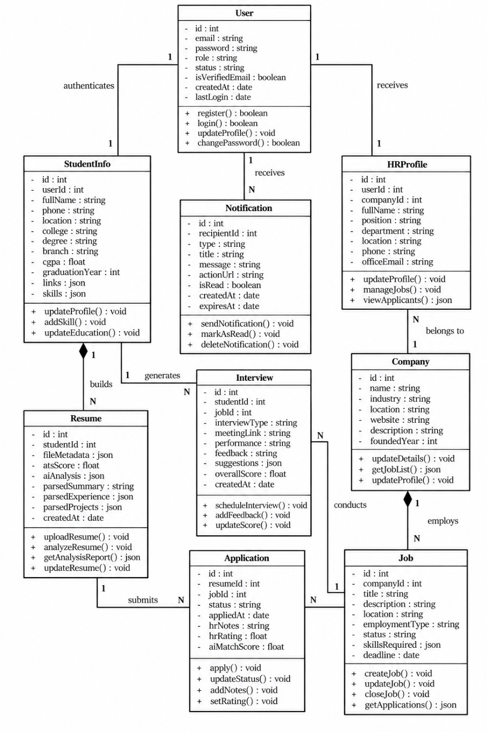
Figure 3.1 Class Diagram of Resume Analysis and Recruitment System
3.2.2 ACTIVITY DIAGRAM

The activity diagram illustrates the workflow of the AI Resume Analysis and Recruitment System through four main participants: Student/Candidate, Platform System, Recruiter/HR, and Admin. Each participant performs specific activities, and the platform coordinates authentication, data storage, resume analysis, job matching, and application management. The process begins when users log in and access their respective dashboards. The platform authenticates users and retrieves the required information from the database. This workflow ensures that candidates, recruiters, and administrators can access the functionalities relevant to their roles.
The student or candidate can create or upload a resume and manage it through the resume vault. The platform analyses the resume by evaluating ATS score, formatting, structure, and extracted skills, then generates an analysis report with improvement suggestions. Candidates can improve their resumes and compare them with job descriptions to obtain matching results. They can browse suitable job opportunities, apply for jobs, and track application status. The platform stores applications, updates their status, and sends notifications regarding application progress and interview schedules. Candidates can also access learning resources and practise through AI mock interviews.

The recruiter can manage the company profile, publish job postings, review applicants, and use AI-assisted screening to evaluate candidate compatibility. Based on the screening results, candidates may be shortlisted for interviews, while unsuccessful applications are updated accordingly. The recruiter can schedule interviews, manage the recruitment process, and view recruitment analytics and reports. Meanwhile, the administrator manages users, job content, system settings, and platform activity. Overall, the activity diagram explains how candidate activities, recruitment operations, and administrative tasks interact to support the complete recruitment workflow.

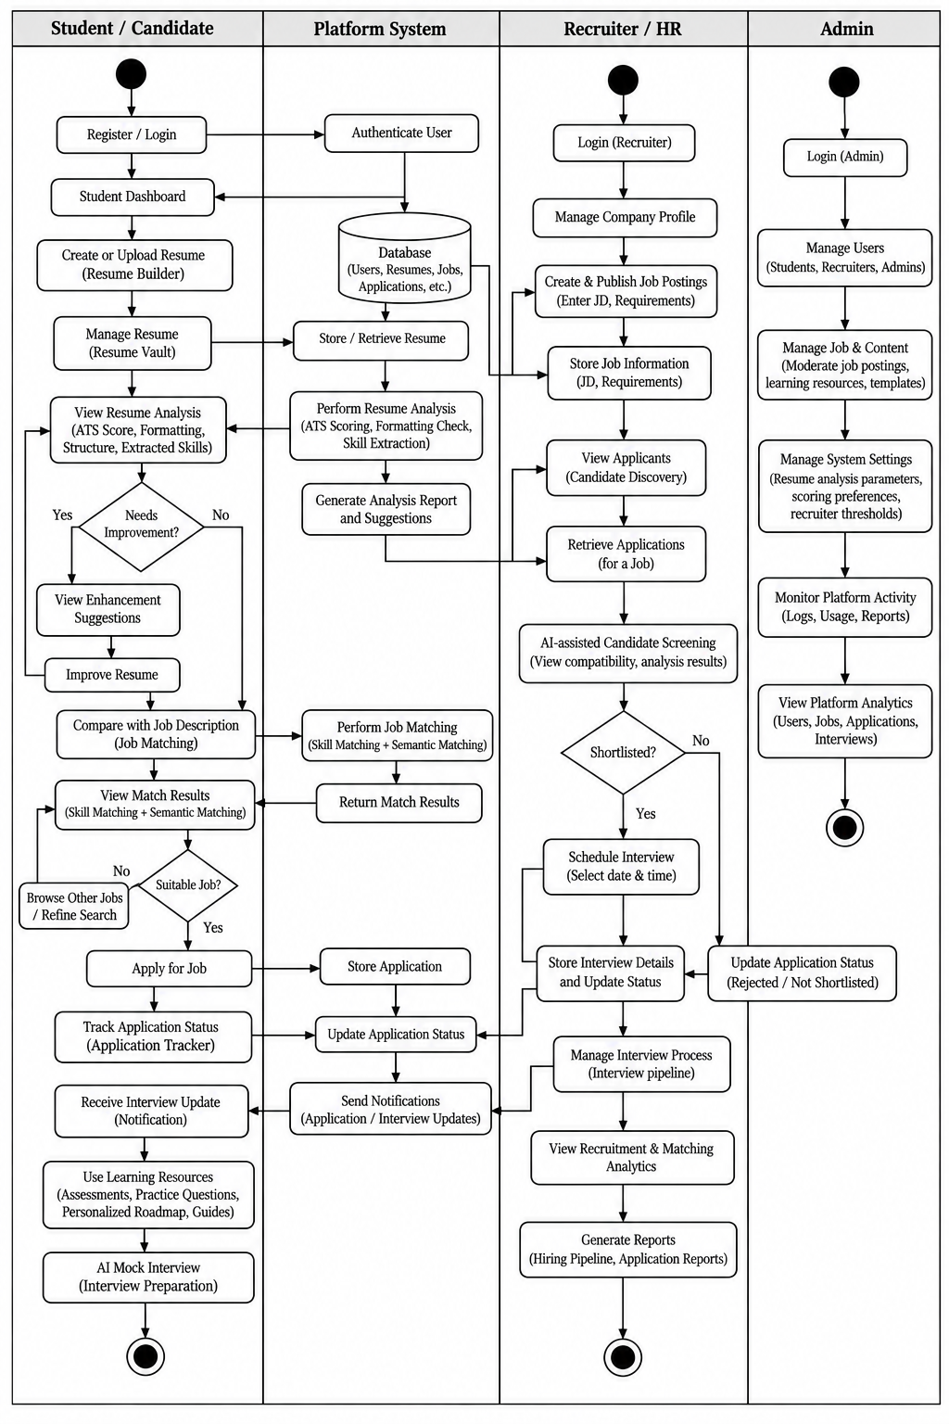
Figure 3.2 Activity Diagram of Resume Analysis and Recruitment System
3.2.3 SEQUNENCE DIAGRAM

The sequence diagram of the AI Resume Analysis and Recruitment System illustrates the interactions between the Student, ResumeService, AnalysisEngine, MatchingEngine, RecruiterService, Database, and NotificationService. It explains how these components communicate through requests and responses to complete resume analysis, job matching, application processing, and interview scheduling. The diagram is divided into three major flows, showing the sequence of operations performed by each component and how information is exchanged between them.

In the resume upload and analysis flow, the student uploads a resume through ResumeService. The file is validated and stored in the database, after which the AnalysisEngine extracts the resume content and calculates the ATS score. It then generates an analysis report and saves the results in the database. The analysis report and score are returned to the student for review. In the job matching and application flow, the student searches for suitable jobs using filters. RecruiterService retrieves the available job details from the database, while MatchingEngine compares the resume with the job requirements using semantic matching. The matching score is returned, helping the student identify relevant opportunities. When the student applies for a job, the application is stored in the database and a notification is sent through NotificationService.

In the candidate screening and interview flow, RecruiterService retrieves applications for a particular job and sends candidate details to the AnalysisEngine for screening. The engine assesses the candidate’s qualifications and returns the screening result to the recruiter. Based on the result, the recruiter can schedule an interview and update the application status in the database. NotificationService sends the interview notification to the relevant user, keeping them informed about the next step. The student can then accept the interview, and the system records the confirmation. Overall, the sequence diagram demonstrates how the system components work together to manage the complete process, from resume submission to candidate screening and interview coordination.

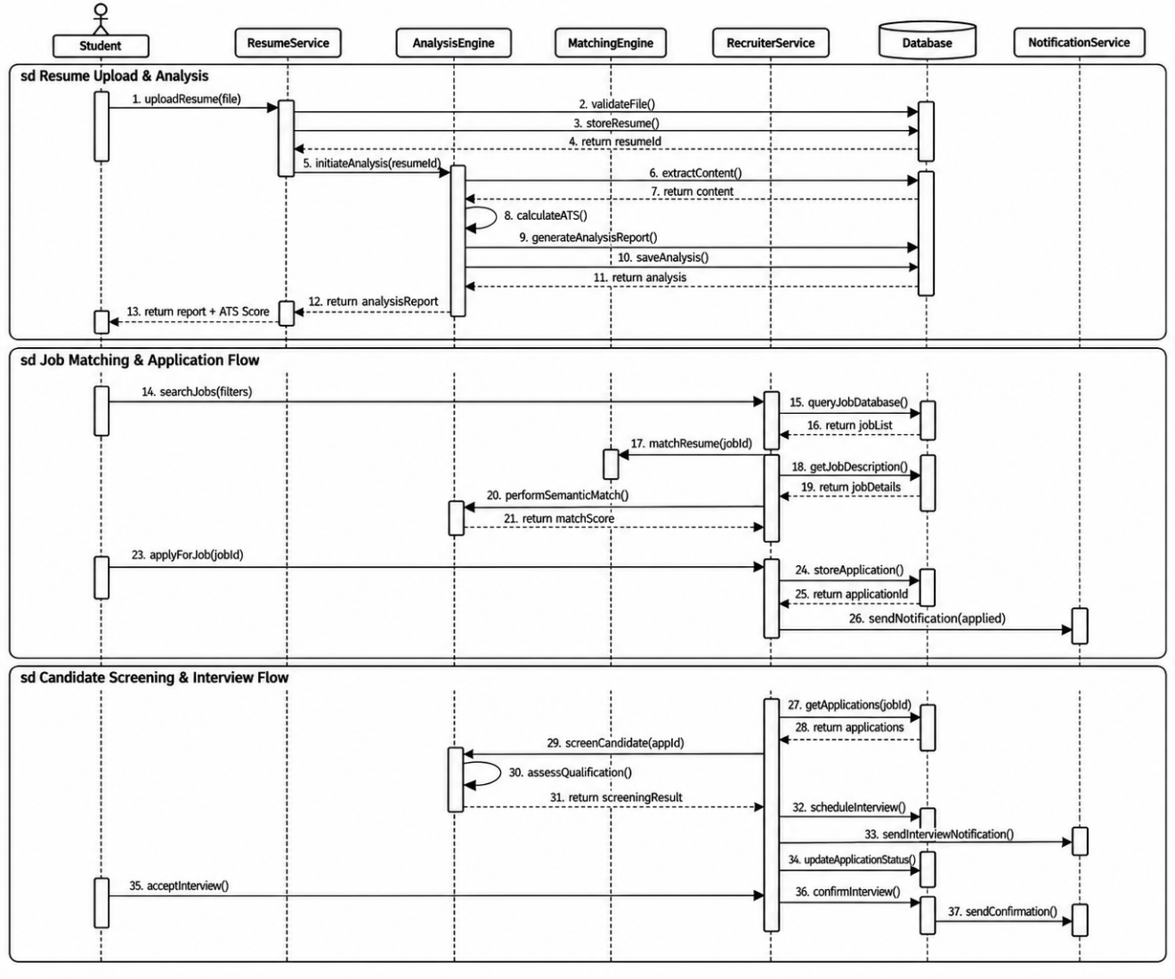
Figure 3.3 Sequen Diagram of Resume Analysis and Recruitment System
3.2.4 USECASE DIAGRAM

The use case diagram of the AI Resume Analysis and Recruitment System illustrates the interactions between three main actors: Student/Candidate, Recruiter/HR, and Admin. Students can register and log in, upload or manage their resumes, view analysis reports, search for suitable jobs, apply for positions, and track their application status. The system extracts resume content, calculates ATS scores, evaluates formatting and skills, and provides suggestions for improvement. Candidates can also compare their resumes with job descriptions to identify suitable opportunities and receive notifications about application updates.
The Recruiter/HR actor can log in, manage the company profile, create job postings, and specify job descriptions and requirements. Recruiters can search for candidates, review resume analysis and matching scores, screen applicants using AI-assisted features, manage application status, and schedule interviews. These functions help recruiters identify suitable candidates and organize the recruitment process efficiently. The system also supports interview coordination and provides recruitment analytics and reports to assist hiring decisions.

The Admin is responsible for managing user accounts, including students, recruiters, and administrators, as well as moderating job postings and managing platform content. The administrator can monitor system activity through logs and reports, generate platform analytics, and configure system settings such as resume analysis parameters, scoring preferences, and recruitment thresholds. The diagram uses include and extend relationships to represent the connections between main activities and their supporting or conditional functions. Overall, it presents the responsibilities of all three actors and demonstrates how their interactions contribute to resume evaluation, candidate selection, and recruitment management.

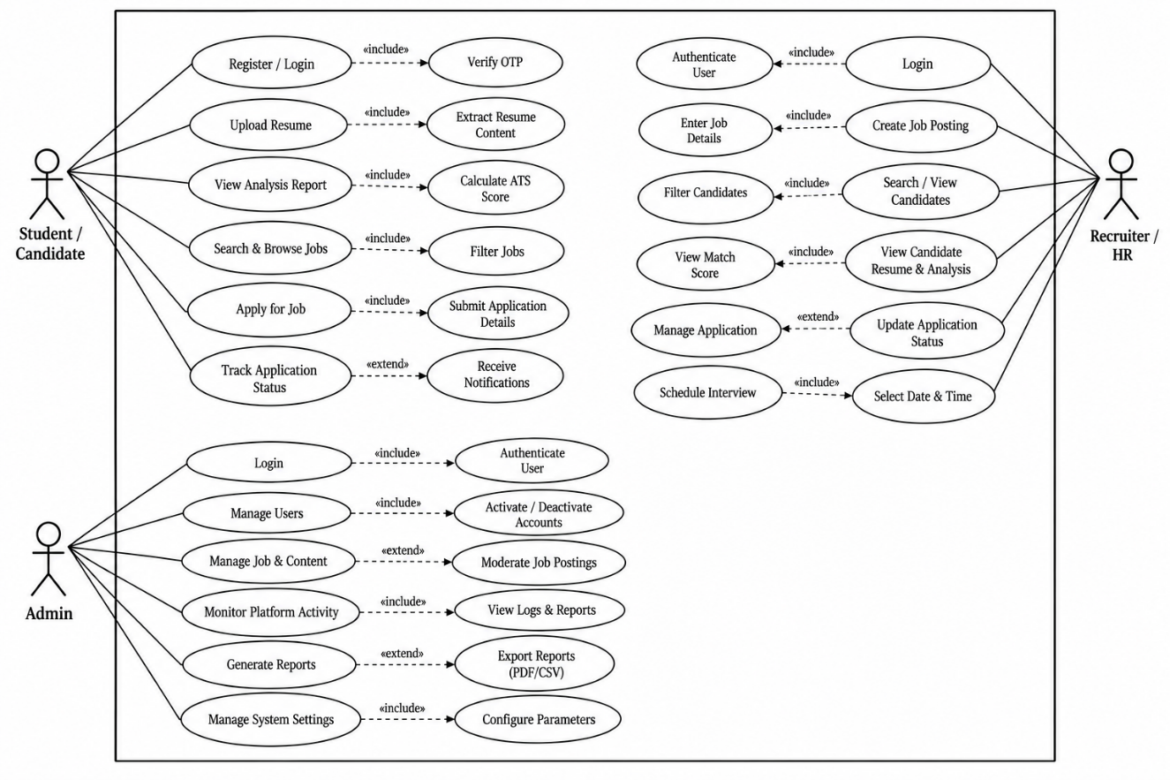

Figure 3.4 Usecase Diagram of Resume Analysis and Recruitment System

3.3 DESIGN COMPONENTS

3.3.1 Front End:

The front-end of the AI Resume Analysis and Recruitment System is developed using React.js, Vite, and Tailwind CSS, providing an interactive and user-friendly web interface. It is responsible for handling user interactions and presenting system functionalities through graphical screens. The interface includes login and registration pages, student and recruiter dashboards, resume analysis screens, job matching interfaces, and interview practice modules.

The system uses React components and Tailwind CSS to create reusable interface elements and maintain a consistent layout. Users can upload resumes, view ATS scores, identify missing skills, receive improvement suggestions, practise interviews, and review their performance. Recruiters can access job-related features and screen candidate resumes through their dashboard. Overall, the front end provides a convenient interface for accessing the system's features and interacting with the analysis results.

3.3.2 Back End:

The back end of the AI Resume Analysis and Recruitment System is implemented using Python and FastAPI. It handles API requests, processes uploaded resumes, manages application operations, and connects the front end with the AI and machine learning modules. It supports functionalities such as resume parsing, ATS analysis, job-description matching, candidate screening, and interview practice.

The system uses libraries such as spaCy for natural language processing and skill extraction, and Sentence Transformers for generating semantic embeddings to compare resumes with job descriptions. FAISS supports vector similarity search, while machine learning components contribute to candidate matching. The system also integrates Google Gemini for selected AI-assisted features. FastAPI provides API endpoints through which the front end accesses these services. Together, these components support resume evaluation and recruitment workflows within a unified application.
3.4 DATABASE DESCRIPTION

3.4.1 ER DIAGRAM

The ER diagram of the AI Resume Analysis and Recruitment System represents the database structure by illustrating its main entities, attributes, primary keys, foreign keys, and relationships. It provides a clear view of how information is organized and connected within the application. The User entity maintains essential account details, while the Resume entity stores information about uploaded resumes. The Job entity contains job-related details, and the Application entity connects candidates with the positions they apply for. These relationships help organize candidate and recruitment information systematically.

The diagram also represents entities related to resume analysis, interview management, messaging, and notifications. Resume analysis records maintain the results generated from uploaded resumes, including evaluation scores and relevant analysis details. Interview-related records support the management of mock interviews or recruitment interviews, while messaging records maintain communication between users. The Notification entity stores alerts about important activities, such as application updates, shortlisting, and incoming messages. Each entity contains attributes that describe its information, and keys help identify individual records and establish connections between related data.

The relationships between entities enable the system to retrieve and manage information efficiently. For example, a user can upload resumes, submit applications for available jobs, and participate in interview activities, while recruiters can publish job openings and review candidate applications. The use of primary and foreign keys helps maintain data integrity and ensures that related records can be associated correctly. Overall, the ER diagram provides a database-level view of the system and explains how user information, resumes, job applications, analysis results, interviews, messages, and notifications are structured to support the major functionalities of the application.

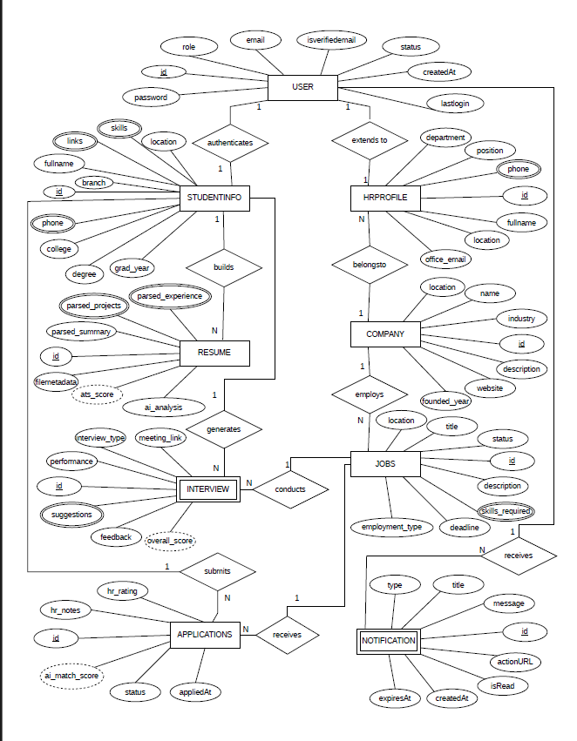

Figure 3.5 : ER Diagram of Resume Analysis and Recruitment System
3.4.2 SCHEMA DESCRIPTION

Table 3.1 : User Description

Attribute Name | Type | Constraint(s) | Description
_id | ObjectId | Primary Key, Not Null, Unique | Unique user account ID
email | String | Not Null, Unique | User email for login and alerts
password_hash | String | Not Null | Hashed password for secure login
full_name | String | Not Null | Complete name of the registered user
role | String | Not Null | User role (student, HR, or admin)
is_active | Boolean | Default: True | Indicates whether account is active
is_verified | Boolean | Default: False | Indicates whether the account is verified
last_login_at | Date | - | Most recent login time
created_at | Date | Not Null | Account registration time
updated_at | Date | - | Last account update time

Table 3.1 represents the User Description table used in the AI Resume Analyzer & Recruitment System. This table serves as the central identity registry storing authentication credentials and account authorization details for all platform users, including students, corporate recruiters, and platform administrators. The `_id` attribute acts as the unique identifier for each user in the database, ensuring every account record can be individually managed and referenced across all relational collections. The `email` attribute is enforced with a unique constraint to prevent duplicate registrations and provide a reliable login key, while the `role` attribute drives authorization boundaries, separating student capabilities from corporate recruitment features.

Table 3.2 : Student Profile Description

Attribute Name | Type | Constraint(s) | Description
_id | ObjectId | Primary Key, Not Null, Unique | Unique student profile ID
user_id | ObjectId | Foreign Key, Not Null, Unique | Linked user account ID
target_role | String | - | Target career role
bio | String | - | Student bio or professional summary
phone | String | - | Contact phone number
location | String | - | Student location
preferred_work_mode | String | - | Preferred work mode
preferred_locations | Array[String] | - | Preferred job locations
profile_completion | Integer | Default: 0 | Profile completion percentage
career_readiness_score | Integer | Default: 0 | Career readiness score
current_streak | Integer | Default: 0 | Current daily activity streak
longest_streak | Integer | Default: 0 | Longest daily activity streak
resume_visibility | String | Default: 'recruiters' | Profile visibility setting
primary_resume_id | ObjectId | Foreign Key | ID of the primary resume
secondary_resume_id | ObjectId | Foreign Key | ID of the secondary resume
updated_at | Date | - | Last profile update time

Table 3.2 represents the Student Profile Description table used in the AI Resume Analyzer & Recruitment System. This table stores extended student career details, work preferences, engagement indicators, and resume associations that augment base user credentials. The `_id` attribute provides a unique primary key for each student profile record, and the `user_id` attribute establishes a one-to-one foreign key link with the corresponding user entry. Key attributes like `career_readiness_score` and `profile_completion` allow the platform to track student preparation progress, while pointers to primary and secondary resumes facilitate fast candidate discovery and streamlined job application workflows.

Table 3.3 : Recruiter Profile Description
Attribute Name | Type | Constraint(s) | Description
_id | ObjectId | Primary Key, Not Null, Unique | Unique recruiter profile ID
user_id | ObjectId | Foreign Key, Not Null, Unique | Linked user account ID
company_id | ObjectId | Foreign Key | Associated company ID
company_name | String | Not Null | Company name
job_title | String | - | Recruiter job title
phone | String | - | Official contact telephone number for business correspondence
website | String | - | Company website URL
industry | String | - | Company industry
company_size | String | - | Company size range
location | String | Not Null | Company location
description | String | - | Company overview
is_verified | Boolean | Default: False | Indicates whether the company is verified
verification_status | String | Default: 'pending' | Company verification status
updated_at | Date | - | Last profile update time

Table 3.3 represents the Recruiter Profile Description table used in the AI Resume Analyzer & Recruitment System. This table captures organizational information and professional credentials for human resource managers and corporate recruiters. The `_id` attribute acts as the unique identifier for each recruiter record, and `user_id` securely binds the organizational profile to an authenticated user account. Fields such as `company_name`, `industry`, and `verification_status` ensure transparency and candidate safety by validating corporate authenticity before job listings can be published and candidate applications reviewed.

Table 3.4 : Resume Description
Attribute Name | Type | Constraint(s) | Description
_id | ObjectId | Primary Key, Not Null, Unique | Unique resume ID
student_id | ObjectId | Foreign Key, Not Null | ID of the resume owner
name | String | Not Null | Resume label
original_file_name | String | Not Null | Original uploaded filename
file_type | String | Not Null | Uploaded file format
file_size | Integer | Not Null | File size in bytes
cloudinary_url | String | Not Null | Cloudinary file URL
cloudinary_public_id | String | Not Null | Cloudinary asset ID
slot | String | Default: 'primary' | Resume slot (primary or secondary)
is_primary | Boolean | Default: True | Indicates whether this is the primary resume
is_current | Boolean | Default: True | Indicates whether the resume is current
score | Integer | - | Resume quality score (0–100)
ats_score | Integer | - | ATS score (0–100)
status | String | Default: 'uploaded' | Resume processing status
parsed_data | Object | - | Extracted resume data in JSON
created_at | Date | Not Null | Resume upload time
updated_at | Date | - | Last resume update time

Table 3.4 represents the Resume Description table used in the AI Resume Analyzer & Recruitment System. This table manages digital resume documents uploaded by candidates, persisting cloud storage references, file metadata, and parsing stages. The `_id` attribute uniquely identifies each uploaded resume document, while `student_id` enforces user ownership. The `cloudinary_url` and `cloudinary_public_id` attributes securely reference the encrypted external document storage, and the `parsed_data` object stores the extracted text sections necessary for automated natural language processing and job matching.

Table 3.5 : Resume Analysis Description
Attribute Name | Type | Constraint(s) | Description
_id | ObjectId | Primary Key, Not Null, Unique | Unique analysis ID
resume_id | ObjectId | Foreign Key, Not Null | ID of the evaluated resume
overall_score | Integer | Not Null | Overall quality score (0–100)
ats_score | Integer | Not Null | ATS compatibility score (0–100)
section_scores | Object | Not Null | Scores for individual resume sections
strengths | Array[String] | - | Identified resume strengths
warnings | Array[String] | - | Formatting and writing warnings
critical_issues | Array[String] | - | Critical resume issues
matched_keywords | Array[String] | - | Keywords found in the resume
missing_keywords | Array[String] | - | Missing recommended keywords
recommendations | Array[Object] | - | Suggested resume improvements
analysis_version | String | Default: '1.0' | NLP analysis version
created_at | Date | Not Null | Analysis creation time

Table 3.5 represents the Resume Analysis Description table used in the AI Resume Analyzer & Recruitment System. This table maintains in-depth diagnostic feedback and quantitative evaluation scores generated by the AI parsing pipeline upon analyzing candidate resumes. The `_id` attribute provides a unique key for each analysis result, while `resume_id` links the report directly to its parent resume document. Attributes such as `overall_score`, `section_scores`, and categorized arrays (`strengths`, `warnings`, `missing_keywords`) equip students with concrete, data-backed insights to refine their resumes for corporate recruitment.

Table 3.6 : Resume Improvement Description
Attribute Name | Type | Constraint(s) | Description
_id | ObjectId | Primary Key, Not Null, Unique | Unique recommendation ID
resume_id | ObjectId | Foreign Key, Not Null | Related resume ID
student_id | ObjectId | Foreign Key, Not Null | Related student ID
section | String | Not Null | Resume section being improved
original_text | String | Not Null | Original resume text
suggested_text | String | Not Null | Suggested improved text
reason | String | Not Null | Reason for the suggestion
improvement_type | String | Not Null | Improvement type
status | String | Default: 'pending' | Recommendation status
target_role | String | - | Target job role
created_at | Date | Not Null | Recommendation creation time

Table 3.6 represents the Resume Improvement Description table used in the AI Resume Analyzer & Recruitment System. This table records granular, sentence-level rewrite suggestions crafted by the AI assistant to optimize specific resume bullet points. The `_id` attribute uniquely identifies each suggested modification, while `resume_id` and `student_id` preserve document context and user authorization. By maintaining both `original_text` and `suggested_text` along with a user-controlled `status` attribute, students can selectively accept or discard enhancements within the interactive resume builder.

Table 3.7 : Job Description
Attribute Name | Type | Constraint(s) | Description
_id | ObjectId | Primary Key, Not Null, Unique | Unique job listing ID
company_id | ObjectId | Foreign Key, Not Null | Company ID
created_by | ObjectId | Foreign Key, Not Null | Recruiter user ID
title | String | Not Null | Job title
department | String | - | Department name
description | String | Not Null | Job responsibilities and requirements
location | String | Not Null | Job location
work_mode | String | Not Null, Default: 'On-site' | Work mode
experience_min | Integer | Not Null, Default: 0 | Minimum experience in years
experience_max | Integer | Not Null, Default: 2 | Maximum experience in years
salary_min | Integer | - | Minimum salary
salary_max | Integer | - | Maximum salary
required_skills | Array[String] | Not Null | Required skills
preferred_skills | Array[String] | - | Preferred skills
matching_config | Object | Not Null | Weights used for candidate matching
status | String | Default: 'draft' | Job listing status
applicant_count | Integer | Default: 0 | Number of applicants
expires_at | Date | - | Job closing time
created_at | Date | Not Null | Job posting creation time
updated_at | Date | - | Last job update time

Table 3.7 represents the Job Description table used in the AI Resume Analyzer & Recruitment System. This table serves as the primary catalogue for employment listings created and administered by corporate recruiters. The `_id` attribute provides a unique identifier for each job vacancy, and `created_by` identifies the recruiter in charge of the requisition. In addition to standard compensation and qualification parameters, the `matching_config` attribute stores customizable scoring weights that govern how the recommendation and matching algorithms rank candidate applications.

Table 3.8 : Job Application Description
Attribute Name | Type | Constraint(s) | Description
_id | ObjectId | Primary Key, Not Null, Unique | Unique application ID
student_id | ObjectId | Foreign Key, Not Null | Applicant student ID
job_id | ObjectId | Foreign Key, Not Null | Target job ID
resume_id | ObjectId | Foreign Key, Not Null | Submitted resume ID
status | String | Not Null, Default: 'applied' | Current application stage
match_score | Integer | - | Resume-job match score (0–100)
applied_at | Date | Not Null | Application submission time
updated_at | Date | - | Last application update time

Table 3.8 represents the Job Application Description table used in the AI Resume Analyzer & Recruitment System. This table models the recruitment interaction connecting applicants with published job postings. The `_id` attribute uniquely distinguishes each submitted application, while the composite foreign keys `student_id`, `job_id`, and `resume_id` track the applicant, requisition, and exact submitted resume. The `status` attribute maintains the candidate's lifecycle through recruiter screening, shortlisting, and final hiring stages, while the denormalized `match_score` facilitates fast recruiter filtering.

Table 3.9 : Interview Description
Attribute Name | Type | Constraint(s) | Description
_id | ObjectId | Primary Key, Not Null, Unique | Unique interview ID
application_id | ObjectId | Foreign Key, Not Null | Related application ID
student_id | ObjectId | Foreign Key, Not Null | Candidate student ID
job_id | ObjectId | Foreign Key, Not Null | Related job ID
scheduled_by | ObjectId | Foreign Key, Not Null | Interview host ID
scheduled_at | Date | Not Null | Scheduled interview date and time
duration_minutes | Integer | Not Null, Default: 60 | Interview duration in minutes
type | String | Not Null, Default: 'technical' | Interview type
status | String | Default: 'scheduled' | Interview status
meeting_url | String | - | Online meeting URL
notes | String | - | Recruiter notes and feedback
created_at | Date | Not Null | Interview creation time
updated_at | Date | - | Last interview update time

Table 3.9 represents the Interview Description table used in the AI Resume Analyzer & Recruitment System. This table records formal corporate interview rounds scheduled by hiring managers for shortlisted job candidates. The `_id` attribute acts as the unique identifier for each scheduled interview record, while `application_id` connects the interview to the overarching application workflow. Logistics such as `scheduled_at`, `duration_minutes`, `type`, and `meeting_url` coordinate online discussions, and the `notes` attribute allows interviewers to document candidate impressions and hiring recommendations.

Table 3.10 : Mock Interview Description
Attribute Name | Type | Constraint(s) | Description
_id | ObjectId | Primary Key, Not Null, Unique | Unique mock interview ID
student_id | ObjectId | Foreign Key, Not Null | Student ID
target_role | String | Not Null | Target job role
type | String | Not Null, Default: 'general' | Interview focus
difficulty | String | Not Null, Default: 'medium' | Difficulty level
status | String | Default: 'in_progress' | Practice status
overall_score | Integer | - | Overall score (0–100)
communication_score | Integer | - | Communication score
technical_depth | Integer | - | Technical depth score
confidence_level | Integer | - | Confidence score
general_feedback | String | - | Overall feedback
questions | Array[Object] | - | Questions, answers, and scores
created_at | Date | Not Null | Practice start time
completed_at | Date | - | Practice completion time

Table 3.10 represents the Mock Interview Description table used in the AI Resume Analyzer & Recruitment System. This table facilitates the AI-powered mock interview practice portal, where students can rehearse answers to customized interview questions without high-stakes pressure. The `_id` attribute uniquely identifies each simulation record, and `student_id` associates the practice history with a specific learner. Storing simulated question prompts alongside candidate responses and multi-dimensional scores (`communication_score`, `technical_depth`) allows students to systematically pinpoint weaknesses and build confidence.

Table 3.11 : Notification Description
Attribute Name | Type | Constraint(s) | Description
_id | ObjectId | Primary Key, Not Null, Unique | Unique notification ID
user_id | ObjectId | Foreign Key, Not Null | Recipient user ID
type | String | Not Null | Notification type
title | String | Not Null | Notification title
message | String | Not Null | Notification message
icon | String | Default: 'info' | Notification icon type
action_url | String | - | Optional action URL
related_entity_type | String | - | Related entity type
related_entity_id | ObjectId | - | Related entity ID
priority | String | Default: 'medium' | Notification priority
is_read | Boolean | Default: False | Indicates whether notification is read
created_at | Date | Not Null | Notification creation time

Table 3.11 represents the Notification Description table used in the AI Resume Analyzer & Recruitment System. This table stores information related to real-time notifications and alerts generated within the system. Notifications inform users about critical recruitment events, such as application reviews, newly posted job matches, and scheduled interviews. The `_id` attribute acts as the unique identifier for each notification record in the database, while the `user_id` field routes the alert to the appropriate recipient. Contextual attributes such as `related_entity_type` and `action_url` enable users to jump directly to the relevant record with a single click.

Table 3.12 : ATS Analysis Description
Attribute Name | Type | Constraint(s) | Description
_id | ObjectId | Primary Key, Not Null, Unique | Unique ATS report ID
resume_id | ObjectId | Foreign Key, Not Null | ID of the evaluated resume
overall_score | Integer | Not Null | Overall ATS score (0–100)
section_detection_score | Integer | Not Null | Section detection score (0–100)
keyword_coverage_score | Integer | Not Null | Keyword coverage score (0–100)
formatting_score | Integer | Not Null | Formatting score (0–100)
readability_score | Integer | Not Null | Readability score (0–100)
contact_info_score | Integer | Not Null | Contact information score (0–100)
checks | Array[Object] | - | Parser validation checks
matched_keywords | Array[String] | - | Keywords found in resume
missing_keywords | Array[String] | - | Missing role-specific keywords
formatting_warnings | Array[String] | - | Formatting warnings
recommendations | Array[String] | - | ATS improvement suggestions
created_at | Date | Not Null | ATS scan time

Table 3.12 represents the ATS Analysis Description table used in the AI Resume Analyzer & Recruitment System. This table stores the granular diagnostic outputs generated by simulating modern Applicant Tracking System parsers against candidate resumes. The `_id` attribute provides a unique identifier for each ATS assessment run, linked to a specific resume via `resume_id`. By isolating metrics across section detection, keyword coverage, and formatting integrity, this table helps candidates detect structural flaws and hidden parsing barriers that could cause premature automated filtering by corporate HR systems.
3.5 USER INTERFACE DESIGN

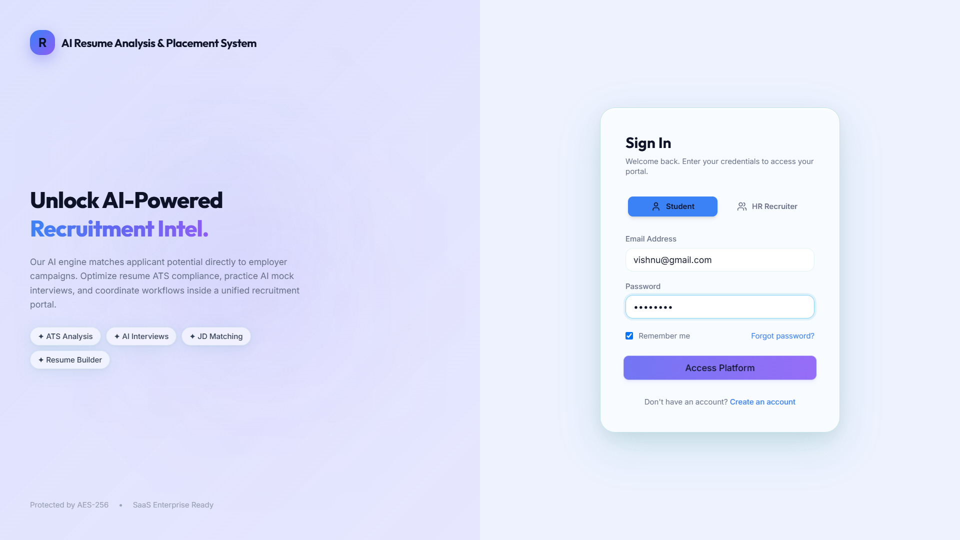

Figure 3.6 Login Page

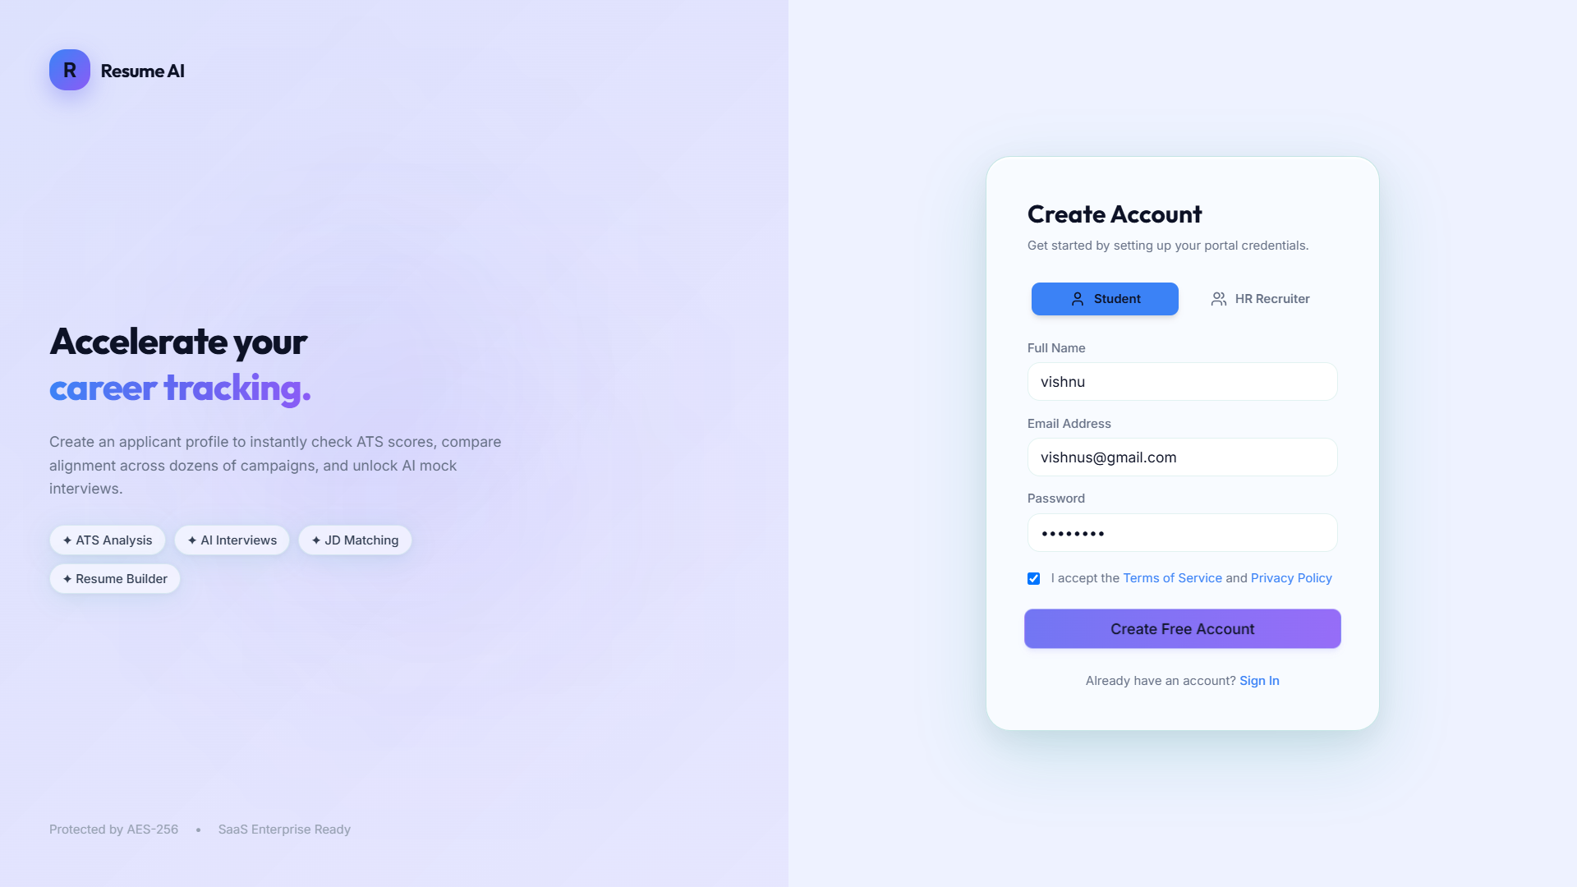

Figure 3.6 Sign Up Page

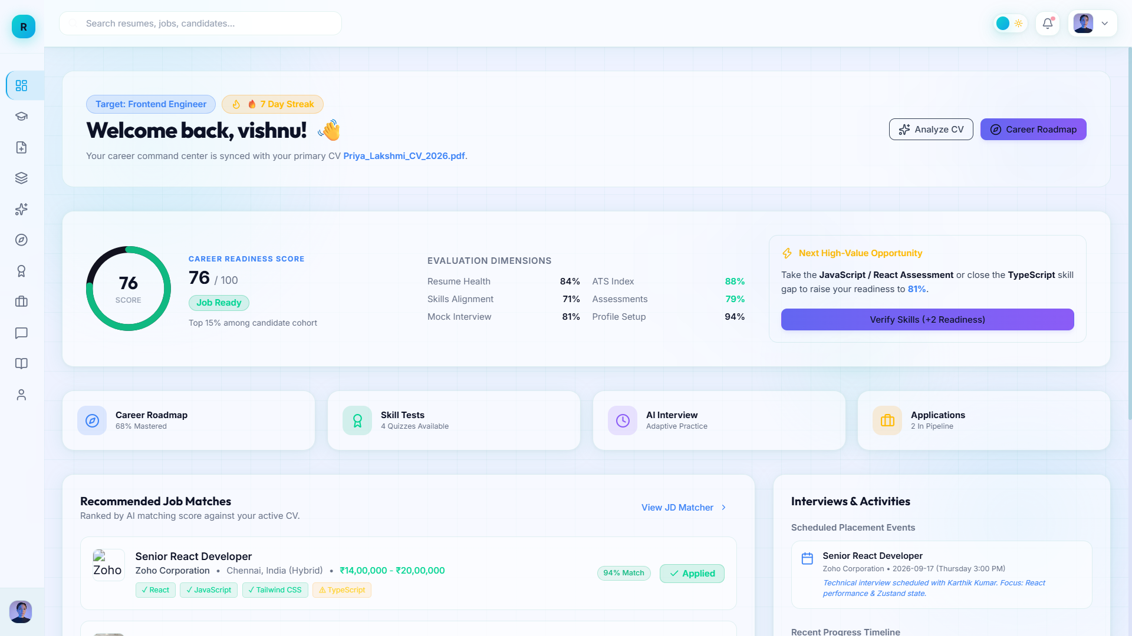

Figure 3.6 Student Dashboard Page
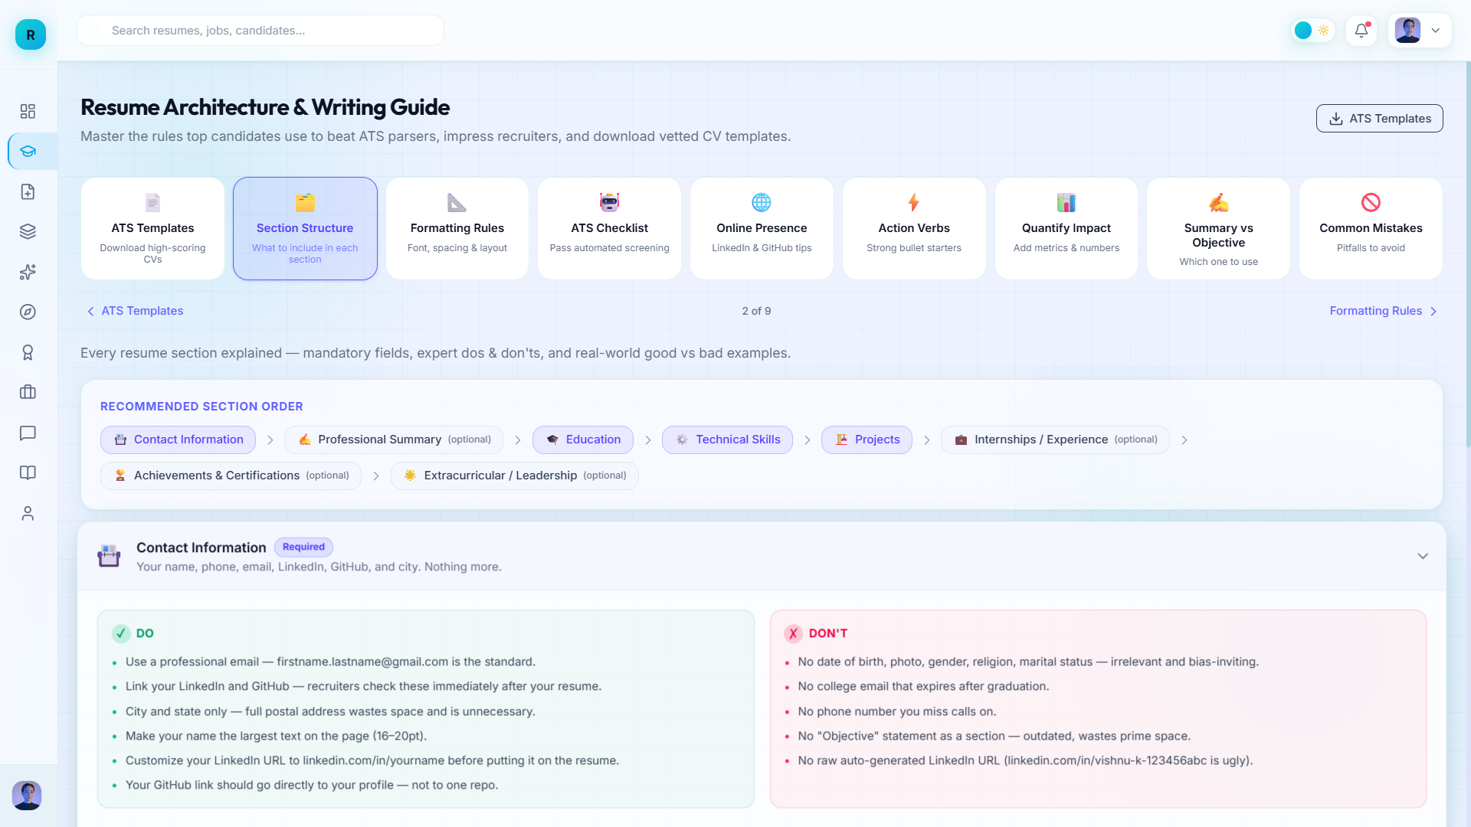
Figure 3.6 Student Resume Builder Guide Page

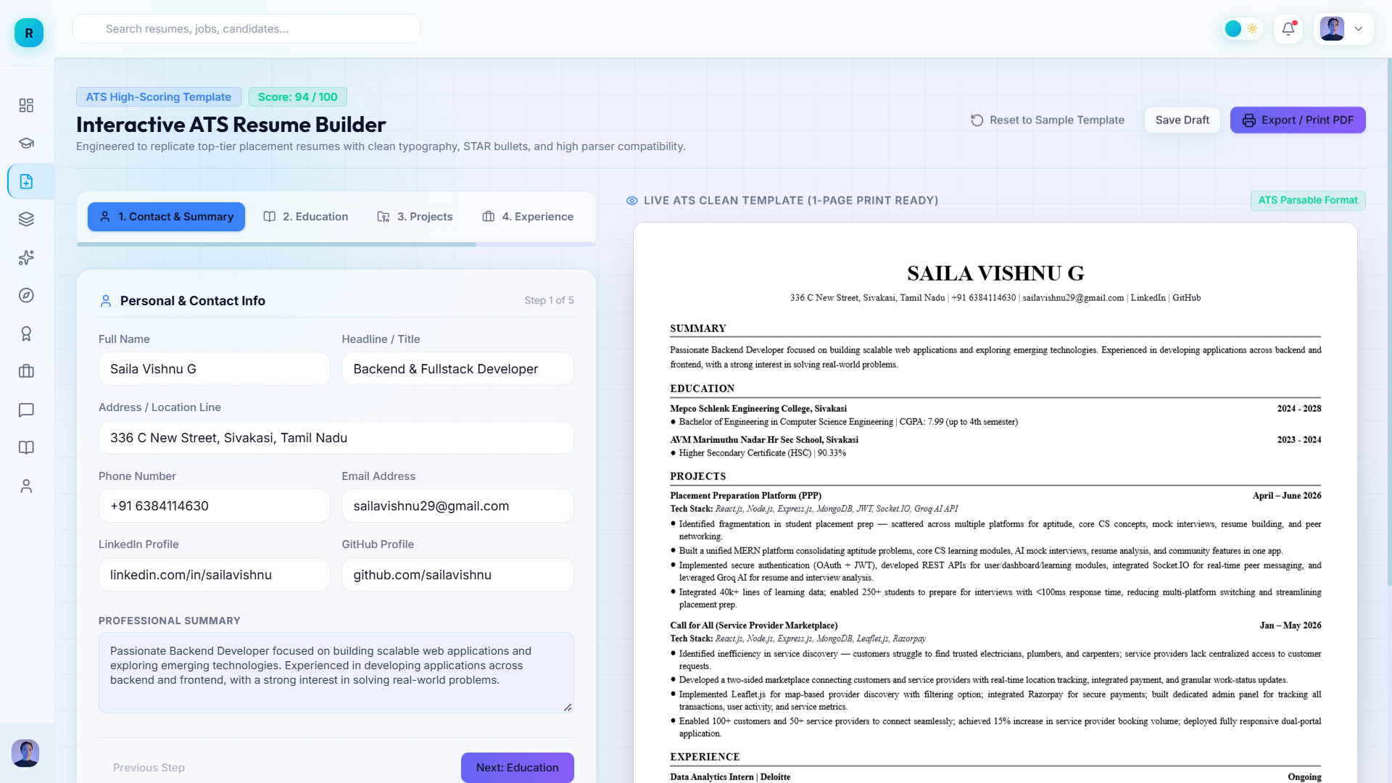

Figure 3.6 Student Resume Builder Page

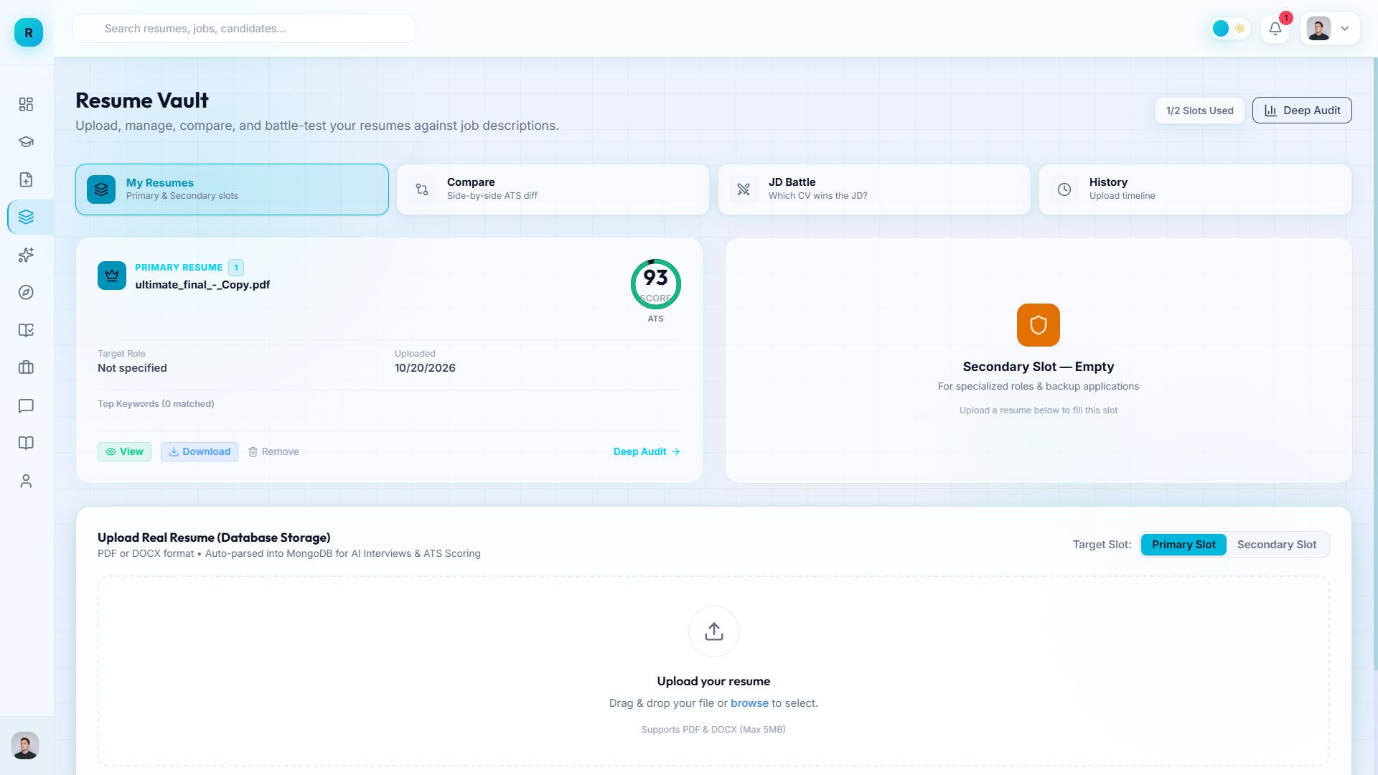

Figure 3.6 Student Resume Uploading Page

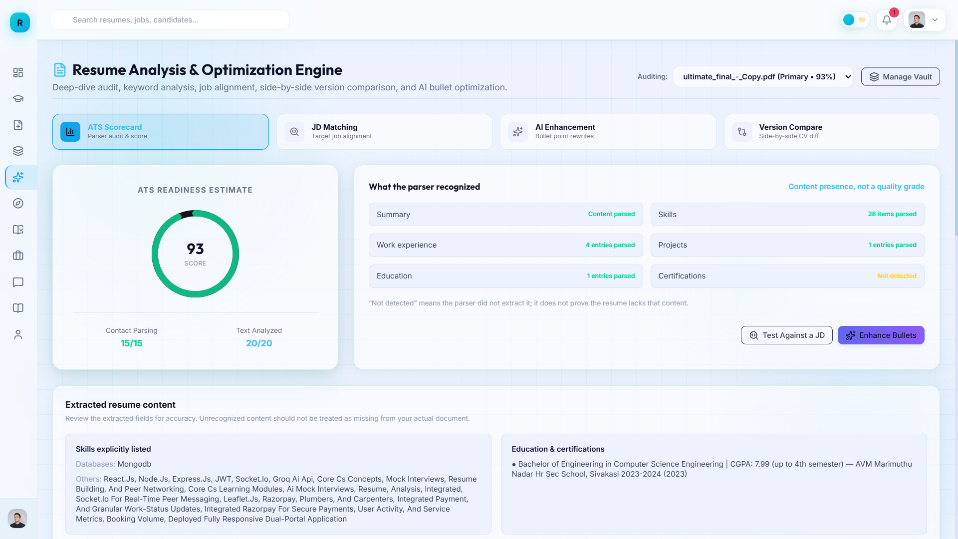

Figure 3.6 Student Resume Analysis Page

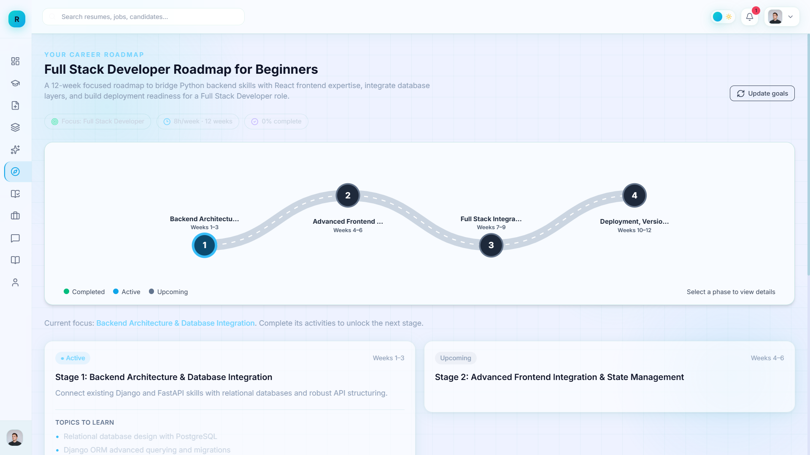

Figure 3.6 Student Personal Roadmap Page

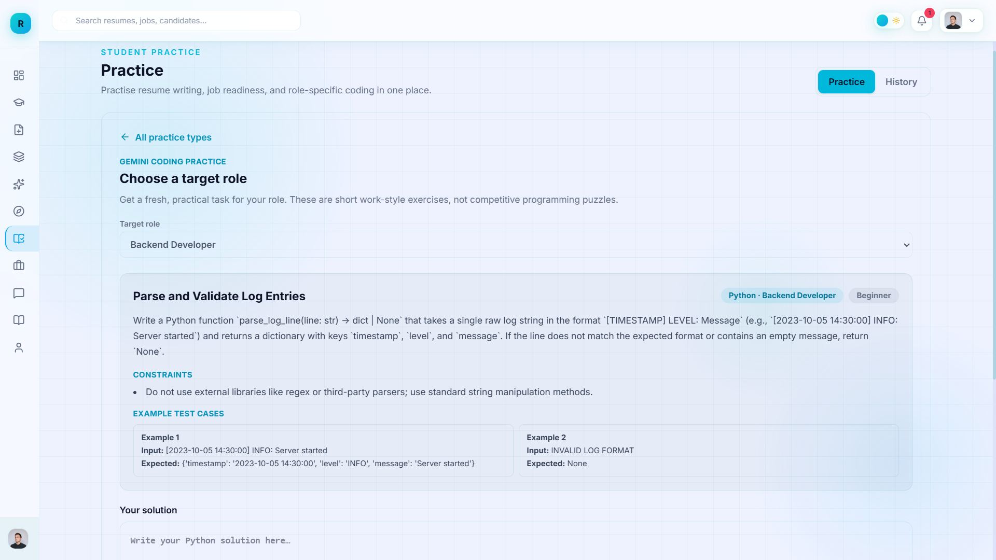

Figure 3.6 Student Self Practicing Page

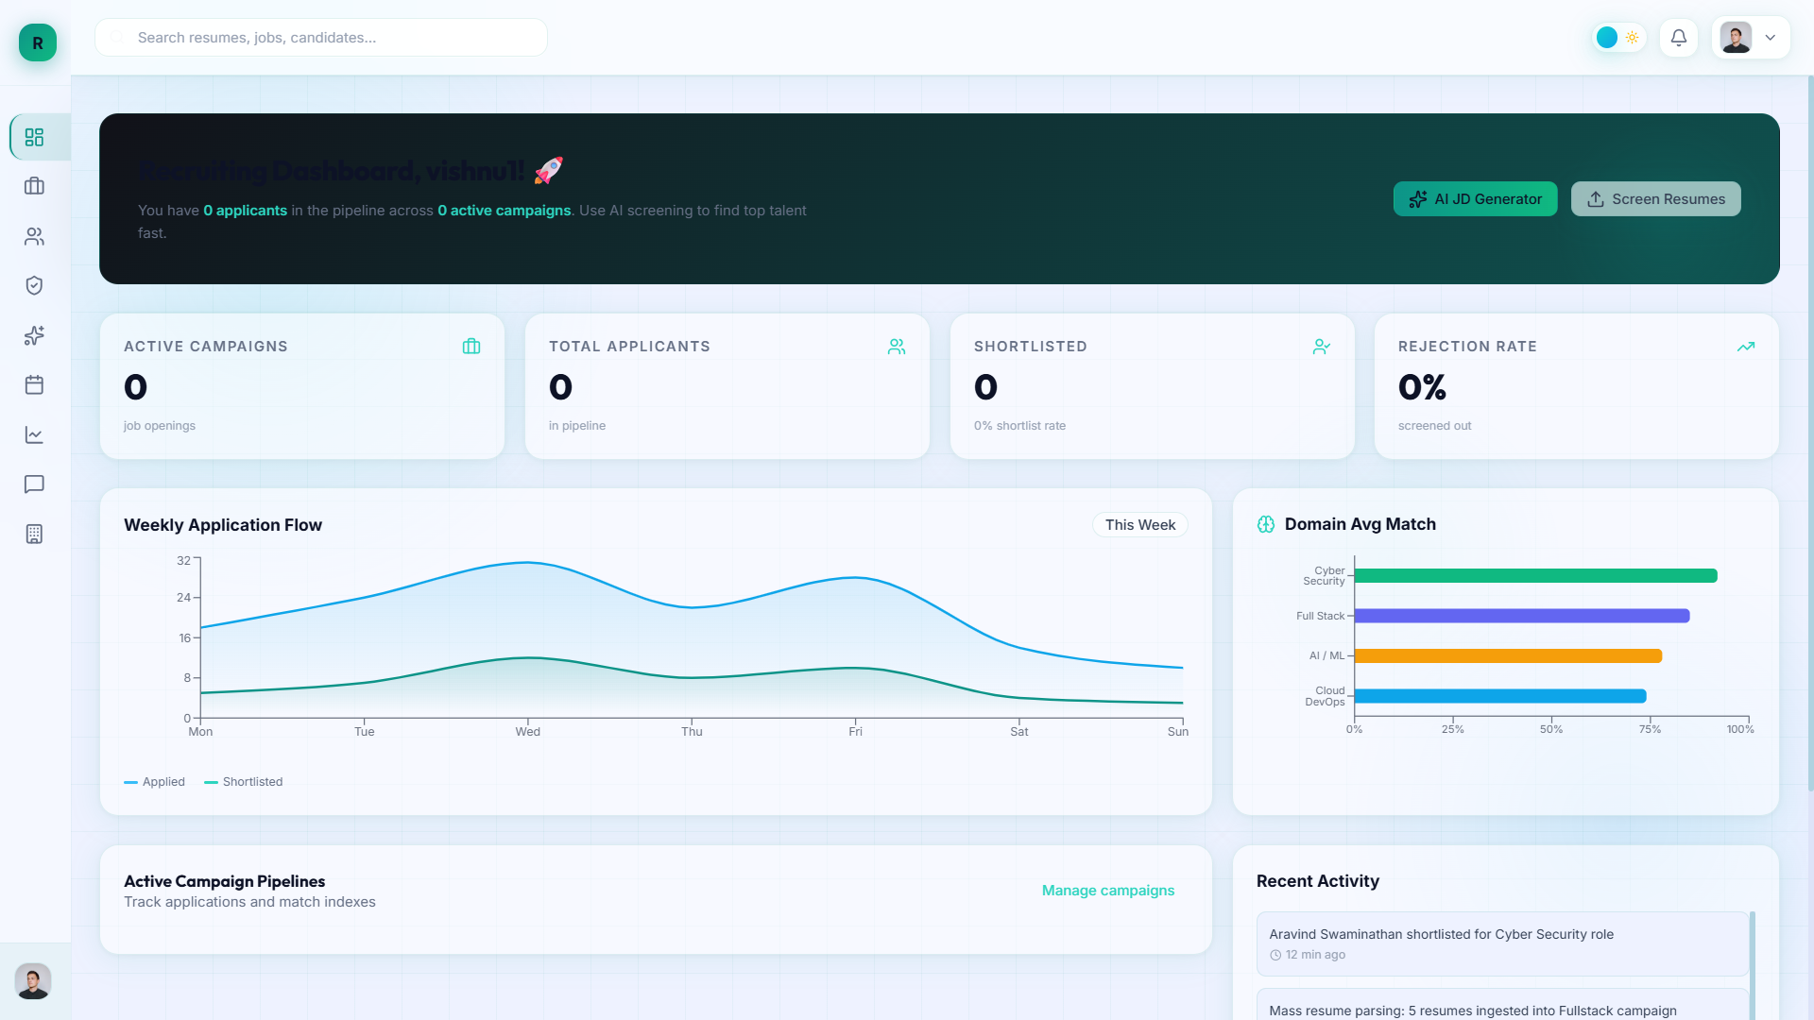

Figure 3.6 Recruiter Dashboard Page

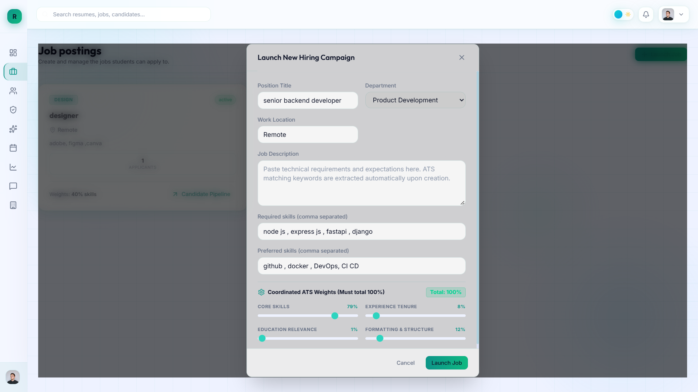

Figure 3.6 Recruiter New Job Opening Page

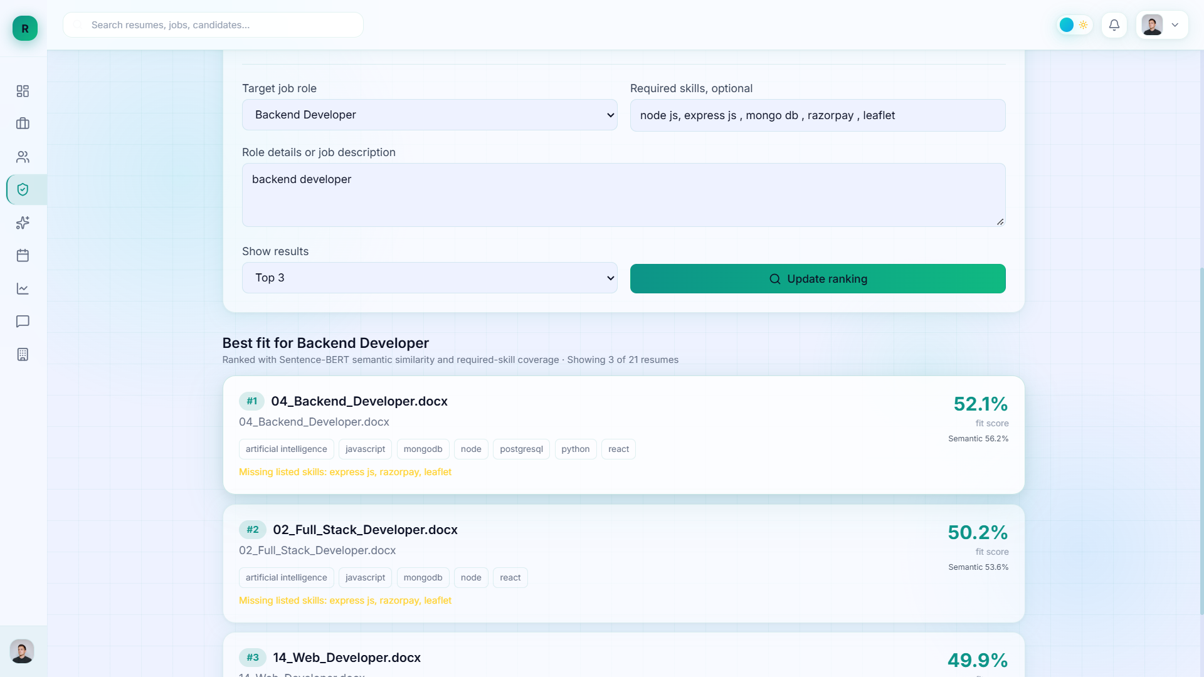
Figure 3.6 Recruiter AI Bulk Resume Screening Page

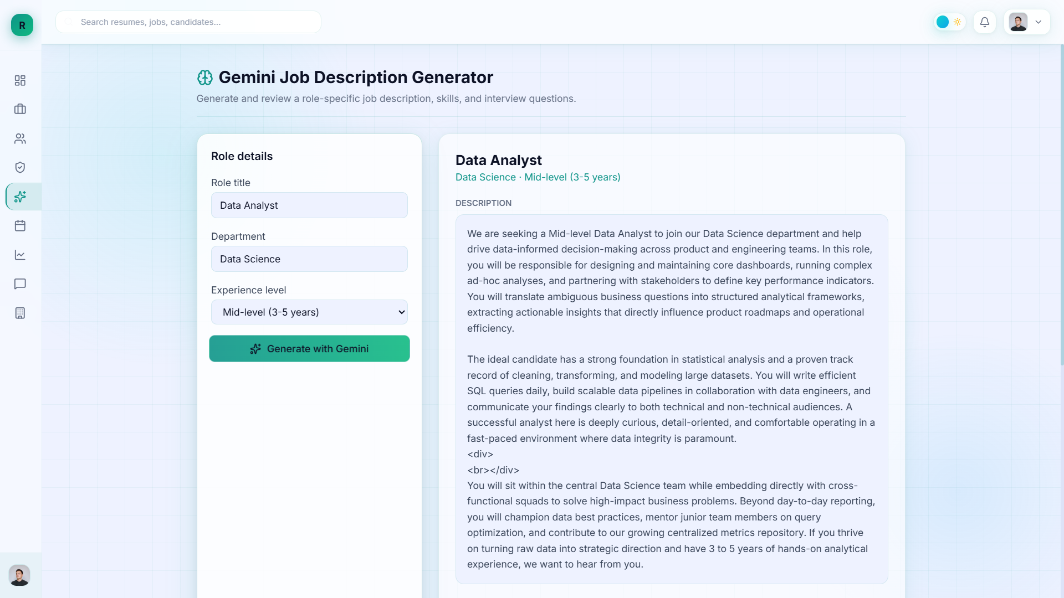

Figure 3.6 Recruiter JD Generator Page

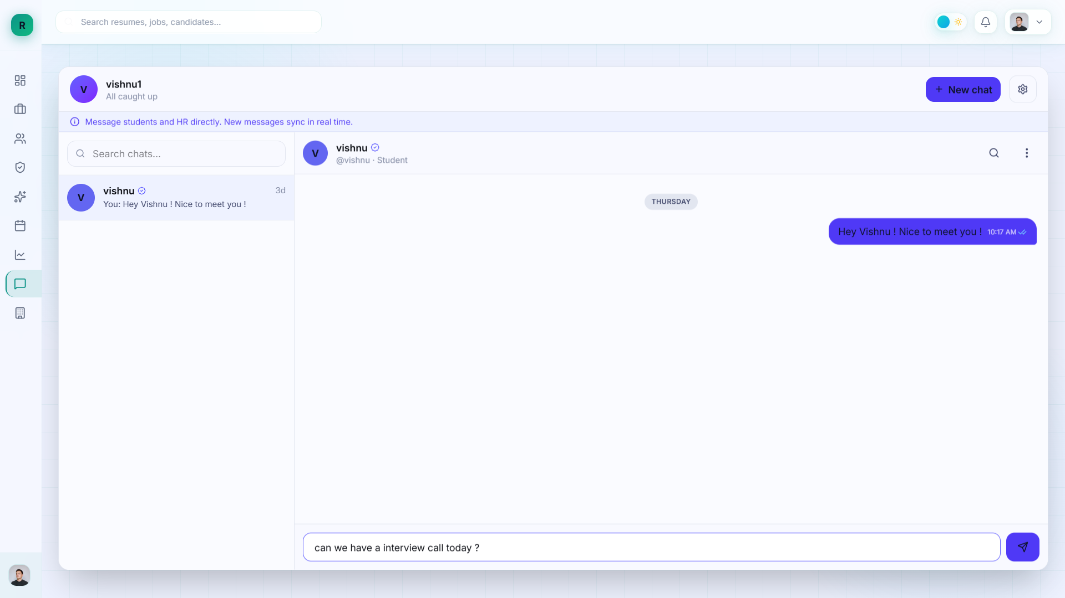

Figure 3.6 In Person Messaging Page

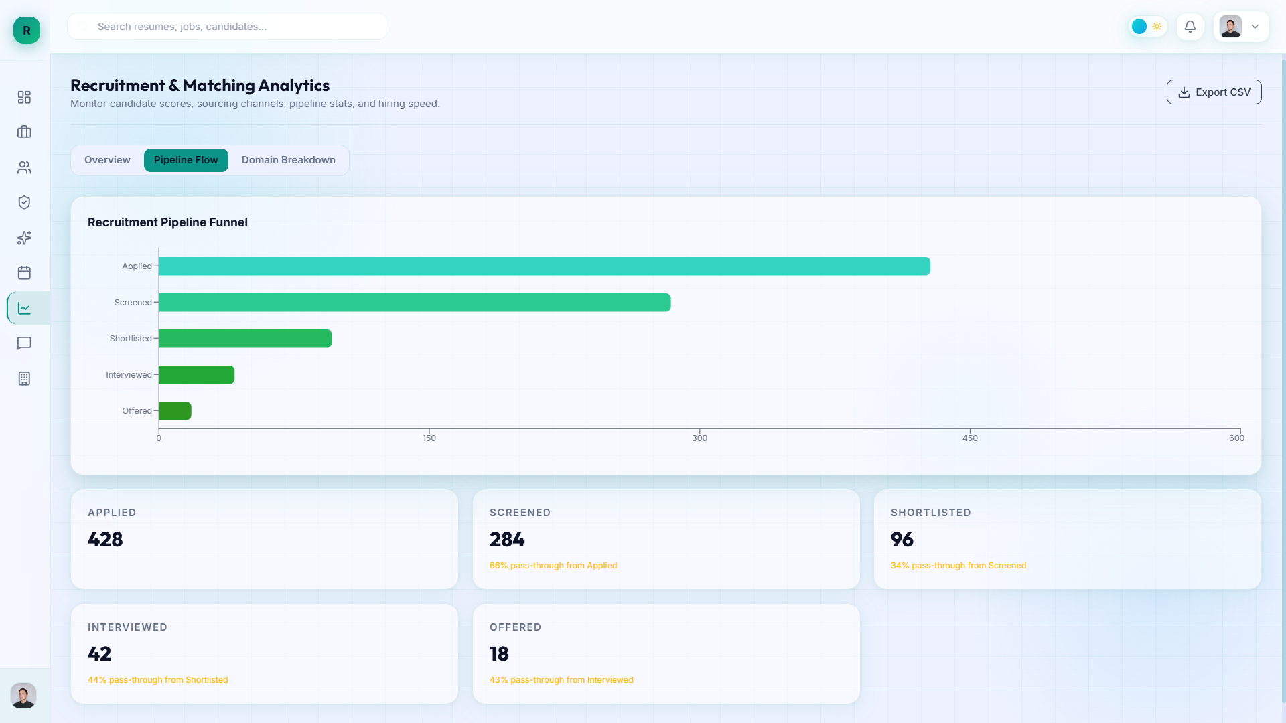

Figure 3.6 Recruiter Analysis Dashboard Page

CHAPTER4

SYSTEM IMPLEMENTATION
4.1 LOGIN IMPLEMENTATION
The login module authenticates registered users using their Gmail address and password. The system checks the submitted credentials against the stored account details. If both are valid, the user is allowed to access the application; otherwise, an error message is displayed.
GET gmail, password
IF gmail and password are valid
RETURN Dashboard
ELSE
TOAST Invalid Gmail or Password
4.2 SIGN UP IMPLEMENTATION
The signup module allows a new user to register by entering a username, Gmail address, and password. The system validates the required fields and checks whether the Gmail address is already registered. If the details are valid, the account is created; otherwise, an appropriate error message is shown.
GET username, gmail, password
IF all fields are valid AND gmail is not registered
CREATE user account
RETURN Registration Successful
ELSE
TOAST Invalid or Already Registered Details
4.3 RESUME ANALYSIS IMPLEMENTATION
The resume analysis module allows a user to upload a resume in PDF or DOCX format with a file size below 10 MB. The system extracts the resume content and generates an analysis that the user can review. The user can also enhance the resume content and compare it with a selected job description to understand how well it matches the target role.

GET resume file
IF file format is PDF or DOCX AND size < 10 MB
EXTRACT resume text
GENERATE resume analysis
DISPLAY analysis and enhancement options
IF job description is provided
COMPARE resume with job description
DISPLAY match results
ELSE
TOAST Upload a valid PDF or DOCX below 10 MB
4.4 AI MOCK INTERVIEW IMPLEMENTATION
The AI mock interview module allows users to practise interview questions based on their chosen role. A user can select a role and upload a resume, or select a role and choose a topic for the questions. Based on the selected option, the system presents interview questions and allows the user to submit responses for practice.
GET selectedRole, interviewOption
IF selectedRole is provided
IF resume is uploaded OR topic is selected
GENERATE role-based interview questions
DISPLAY questions
GET user responses
PROCESS responses
ELSE
TOAST Upload a resume or select a topic
ELSE
TOAST Select an interview role
4.5 MESSAGING IMPLEMENTATION
The messaging module allows a user to communicate with another registered user by entering the other person’s username. The system checks whether the username is valid and then provides the conversation interface to send and receive messages. Invalid usernames or unsuccessful message submissions are handled with suitable feedback.
GET recipientUsername, message
IF recipientUsername exists AND message is valid
SAVE message
DISPLAY conversation update
ELSE
TOAST Enter a valid username and message
4.6 NOTIFICATION IMPLEMENTATION
The notification module informs users about important events, such as a shortlisted resume, a new message, or other system alerts. Notifications are displayed in the notification panel. After the user views a notification, the system deletes that notification record from the database, as specified for this application.
GET userID; FETCH notifications
IF notifications are available
DISPLAY notifications
DELETE a notification record after it is viewed
ELSE
DISPLAY No new notifications

CHAPTER 5
RESULT AND DISSCUSION
5.1 TEST CASES AND RESULTS
The following test cases cover positive and negative inputs for the main user and recruiter workflows. The expected output is specified for each case. The result should be marked after the test is executed.
5.1.1 Test Case and Result for Login
Table 5.1: Positive Test Case for Login
Test Case ID | TC1
Test Case Description | Verify login using a registered Gmail address and the correct password.
Test Data | Registered Gmail and correct password
Expected Output | Login succeeds and the dashboard is displayed.
Result | To be verified during execution
Table 5.2: Negative Test Case for Login
Test Case ID | TC2
Test Case Description | Verify that login is rejected when the Gmail address or password is incorrect.
Test Data | Registered Gmail with an incorrect password, or an unregistered Gmail
Expected Output | Login is rejected and an error message is displayed.
Result | To be verified during execution

5.1.2 Test Case and Result for Resume Analysis

Table 5.3: Positive Test Case for Resume Analysis
Test Case ID | TC3
Test Case Description | Verify resume analysis with a supported file below the size limit.
Test Data | Valid PDF or DOCX resume under 10 MB
Expected Output | Resume is accepted and analysis results are displayed.
Result | To be verified during execution
Table 5.4: Negative Test Case for Resume Analysis
Test Case ID | TC4
Test Case Description | Verify that an unsupported file type or file of 10 MB or more is rejected.
Test Data | TXT file, or a PDF/DOCX file of 10 MB or more
Expected Output | Upload is rejected and a validation message is displayed.
Result | To be verified during execution
Table 5.5: Resume and Job Description Comparison
Test Case ID | TC5
Test Case Description | Verify comparison of an uploaded resume with a job description.
Test Data | Valid resume and job description
Expected Output | Resume-to-job comparison results are displayed.
Result | To be verified during execution
5.1.3 Test Case and Result for AI Mock Interview
Table 5.6: Positive Test Case for AI Mock Interview
Test Case ID | TC6
Test Case Description | Verify starting a mock interview after selecting a role and either uploading a resume or choosing a topic.
Test Data | Selected role and valid resume, or selected role and topic
Expected Output | Role-based interview questions are displayed.
Result | To be verified during execution
Table 5.7: Negative Test Case for AI Mock Interview
Test Case ID | TC7
Test Case Description | Verify that the interview cannot start without a role or without either a resume or a topic.
Test Data | Missing role, or no resume and no topic selected
Expected Output | Interview does not start and a validation message is displayed.
Result | To be verified during execution

5.1.4 Test Case and Result for HR AI Screening
Table 5.8: Positive Test Case for HR AI Screening
Test Case ID | TC8
Test Case Description | Verify HR screening with a ZIP file containing resumes and a selected target role.
Test Data | Valid resume ZIP file and selected target role
Expected Output | Screening is processed and candidate results are displayed.
Result | To be verified during execution
Table 5.9: Negative Test Case for HR AI Screening
Test Case ID | TC9
Test Case Description | Verify that screening is not started when the ZIP file is missing/invalid or the target role is not selected.
Test Data | No ZIP file, invalid archive, or no target role
Expected Output | Screening is rejected and a validation message is displayed.
Result | To be verified during execution
5.1.5 Test Case and Result for Messaging
Table 5.10: Positive Test Case for Messaging
Test Case ID | TC10
Test Case Description | Verify sending a message to an existing user using their username.
Test Data | Valid recipient username and non-empty message
Expected Output | Message is saved and shown in the conversation.
Result | To be verified during execution
Table 5.11: Negative Test Case for Messaging
Test Case ID | TC11
Test Case Description | Verify handling of a nonexistent recipient username or an empty message.
Test Data | Invalid username or empty message
Expected Output | Message is not sent and suitable feedback is displayed.
Result | To be verified during execution
5.1.6 Test Case and Result for Notifications
Table 5.12: Positive Test Case for Notifications
Test Case ID | TC12
Test Case Description | Verify that a user can view the available new notifications.
Test Data | User account with one or more notifications
Expected Output | Available notifications are displayed.
Result | To be verified during execution

Table 5.13: Negative/Empty-State Test Case for Notifications
Test Case ID | TC13
Test Case Description | Verify notification behaviour when no notifications are available.
Test Data | User account with no notifications
Expected Output | A message indicating no new notifications is displayed.
Result | To be verified during execution
Table 5.14: Notification Removal Test Case
Test Case ID | TC14
Test Case Description | Verify that a notification record is deleted after the user views it.
Test Data | Existing notification opened by the user
Expected Output | Viewed notification is removed from the database and no longer appears in the panel.
Result | To be verified during execution
CHAPTER 6

CONCLUSION AND FUTURE ENHANCEMENTS

6.1 CONCLUSION

The development of the AI Resume Analysis and Recruitment System addresses the challenges faced by students in resume preparation and recruiters in candidate screening. By integrating resume analysis, ATS compatibility checking, job-description matching, skill-gap identification, resume improvement suggestions, and interview practice, the system provides a unified platform for career preparation. The use of React.js for the frontend and Python FastAPI for the backend enables the integration of various AI and machine learning techniques to analyse resumes and support candidate evaluation.
In conclusion, the project demonstrates how AI-assisted technologies can simplify resume evaluation and make preliminary recruitment activities more efficient. Students can identify areas for improvement and prepare for interviews, while recruiters can screen resumes and identify candidates relevant to job requirements with reduced manual effort. Although the system provides useful analysis and recommendations, the results depend on the quality of the uploaded resumes and the capabilities of the underlying models. The system is intended to support, rather than replace, human judgement in recruitment decisions.

6.2 FUTURE ENHANCEMENTS

The AI Resume Analysis and Recruitment System can be enhanced in the future by improving resume parsing accuracy, supporting additional document formats, and refining the resume-to-job matching process using larger and more diverse datasets. Further improvements may include advanced performance analytics for mock interviews, additional interview question categories, integration with external job portals, and features for interview scheduling and applicant status tracking. The system can also be strengthened through improvements in security, scalability, and accessibility to support a wider range of users. These enhancements would make the platform more reliable and useful for students and recruiters while ensuring that final recruitment decisions remain under human judgement.
APPENDIX – A
SYSTEM REQUIREMENTS
HARDWARE REQUIREMENT

- Processor: Intel Core i3 or higher, or an equivalent processor.
- RAM: Minimum 4 GB; 8 GB or more is recommended for running the development environment and supporting services.
- Storage: At least 2 GB of free space for source code, dependencies, and application files; additional space may be required for datasets and local database storage.
- Monitor: Standard display with a resolution of 1366 × 768 or higher.
- Input Devices: Standard keyboard and mouse.
SOFTWARE REQUIREMENT

- Operating System: Windows 10/11, Linux, or macOS.
- Frontend: React.js with Vite and Tailwind CSS.
- Backend: Python with FastAPI.
- Database: MongoDB, where configured for application data.
- AI/NLP Libraries: spaCy and Sentence Transformers.
- Vector Search: FAISS.
- Generative AI Service: Google Gemini API for supported AI-assisted features.
- Development Tools: Visual Studio Code or another compatible IDE, Git, and a modern web browser.
- Supporting Packages: Python and JavaScript dependencies specified by the project configuration files.

APPENDIX – B

SOURCE CODE

"""
Authentication API routes.
"""
from fastapi import APIRouter, Depends, HTTPException, status
from app.core.config import settings
from app.core.security import hash_password
from pymongo.database import Database

from app.core.dependencies import get_current_user
from app.cloud.mongodb import get_database
from app.schemas.auth import SignUpRequest, LoginRequest, AdminLoginRequest, TokenResponse, RefreshRequest, MeResponse
from app.schemas.common import DataResponse, MessageResponse
from app.services.auth_service import AuthService
from app.utils.dates import utc_now

router = APIRouter(prefix="/auth", tags=["Authentication"])

@router.post("/signup", response_model=DataResponse[TokenResponse])
async def sign_up(
request: SignUpRequest,
db: Database = Depends(get_database)
):
"""Register a new user account."""
auth_service = AuthService(db)

# Register user
user = await auth_service.register_user(
full_name=request.full_name,
email=request.email,
password=request.password,
role=request.role
)

# Create tokens
tokens = auth_service.create_tokens(user)

return DataResponse(data=TokenResponse(**tokens))

@router.post("/login", response_model=DataResponse[TokenResponse])
async def login(
request: LoginRequest,
db: Database = Depends(get_database)
):
"""Authenticate user and return tokens."""
auth_service = AuthService(db)

# Authenticate
user = await auth_service.authenticate_user(request.email, request.password)

# Create tokens
tokens = auth_service.create_tokens(user)

return DataResponse(data=TokenResponse(**tokens))

@router.post("/admin-login", response_model=DataResponse[TokenResponse])
async def admin_login(request: AdminLoginRequest, db: Database = Depends(get_database)):
"""Authenticate the configured admin and issue a normal, database-backed JWT."""
if not settings.ADMIN_ID or not settings.ADMIN_PASSWORD or not settings.SECRET_KEY:
raise HTTPException(status_code=503, detail="Admin authentication is not configured")
if request.admin_id != settings.ADMIN_ID or request.password != settings.ADMIN_PASSWORD:
raise HTTPException(status_code=401, detail="Invalid admin ID or password")

admin_email = settings.ADMIN_EMAIL.lower()
user = db["users"].find_one({"email": admin_email})
if user is None:
user_doc = {
"email": admin_email,
"password_hash": hash_password(settings.ADMIN_PASSWORD),
"full_name": "Platform Administrator",
"role": "admin",
"is_active": True,
"is_verified": True,
"created_at": utc_now(),
"last_login_at": utc_now(),
}
user_doc["_id"] = db["users"].insert_one(user_doc).inserted_id
user = user_doc
else:
if user.get("role") != "admin" or not user.get("is_active", True):
raise HTTPException(status_code=403, detail="Configured admin account is disabled or has an invalid role")
if not user.get("full_name"):
user["full_name"] = user.get("name") or "Platform Administrator"
db["users"].update_one(
{"_id": user["_id"]},
{"$set": {"full_name": user["full_name"]}},
)

user["id"] = str(user["_id"])
db["users"].update_one({"_id": user["_id"]}, {"$set": {"last_login_at": utc_now()}})
tokens = AuthService(db).create_tokens(user)
return DataResponse(data=TokenResponse(**tokens))

@router.post("/refresh", response_model=DataResponse[TokenResponse])
async def refresh_token(
request: RefreshRequest,
db: Database = Depends(get_database)
):
"""Refresh access token using refresh token."""
# This would verify refresh token and issue new access token
# Simplified implementation for now
raise HTTPException(
status_code=status.HTTP_501_NOT_IMPLEMENTED,
detail="Refresh token endpoint not implemented yet"
)

@router.post("/logout", response_model=MessageResponse)
async def logout(current_user: dict = Depends(get_current_user)):
"""Logout user (invalidate tokens)."""
# In a production system, you'd blacklist the token
# For now, just return success (client should discard token)
return MessageResponse(message="Logged out successfully")

@router.get("/me", response_model=DataResponse[MeResponse])
async def get_current_user_info(current_user: dict = Depends(get_current_user)):
"""Get current authenticated user information."""
user_data = MeResponse(
id=current_user["id"],
email=current_user["email"],
full_name=current_user["full_name"],
role=current_user["role"],
is_active=current_user.get("is_active", True),
is_verified=current_user.get("is_verified", False)
)

return DataResponse(data=user_data)
REFERENCES
[1] I. Goodfellow, Y. Bengio and A. Courville, Deep Learning. Cambridge, MA, USA: MIT Press, 2016.
[2] I. Sommerville, Software Engineering, 10th ed. Boston, MA, USA: Pearson, 2016.
[3] A. Géron, Hands-On Machine Learning with Scikit-Learn, Keras, and TensorFlow, 3rd ed. Sebastopol, CA, USA: O'Reilly Media, 2022.
[4] D. Jurafsky and J. H. Martin, Speech and Language Processing, 3rd ed. Draft, 2024. [Online]. Available: https://web.stanford.edu/~jurafsky/slp3/
[5] Python Software Foundation, “Python Documentation.” [Online].
Available: https://docs.python.org/3/
[6] FastAPI, “FastAPI Documentation.” [Online].
Available: https://fastapi.tiangolo.com/
[7] Meta AI, “FAISS Documentation.” [Online].
Available: https://faiss.ai/
[8] Explosion AI, “spaCy Documentation.” [Online].
Available: https://spacy.io/usage
[9] Sentence Transformers, “Sentence Transformers Documentation.” [Online]. Available: https://sbert.net/
[10] React Team, “React Documentation.” [Online].
Available: https://react.dev/
[11] MongoDB, Inc., “MongoDB Documentation.” [Online].
Available: https://www.mongodb.com/docs/
[12] Google, “Gemini API Documentation.” [Online].
Available: https://ai.google.dev/gemini-api/docs

